Playbook



Andromeda Creative Diversification Playbook


Time to Read: 5 minutes
Implementation Time: 45-60 minutes total (including client communication, asset gathering, editing, and ad manager setup)

MISSION
Combat Meta's Andromeda algorithm update by implementing creative diversification strategies that maintain ad performance and prevent accelerated ad fatigue for our clients.

Meta's Andromeda update has fundamentally changed how Facebook's algorithm processes and distributes ads, requiring 8+ creatives (can easily have up to 15-20+) creatives per ad set instead of the traditional 6-8 to maintain optimal performance.

PREFACE
The Andromeda update has created accelerated ad fatigue across multiple markets, particularly affecting high-spend accounts. We're seeing this impact most severely in:

- Klaus Roofing Systems of Texas Hill Country (New Braunfels, Central Texas)
- Timberland Exteriors (Minneapolis, Minnesota)
- Multiple Colorado markets (Denver, Colorado Springs)

Ad fatigue now occurs around $4,000-$6,000 in ad spend instead of the previous $10,000+ threshold. This SOP provides a systematic approach to building creative surplus and maintaining consistent lead flow.

MINDSET SHIFT
From Reactive to Proactive: Instead of scrambling for new creatives when ad fatigue hits, we maintain creative surplus - always having more creatives than needed. This prevents the worst-case scenario of asking clients for emergency assets while dealing with declining performance.

Creative Surplus = Competitive Advantage: Having 15-20 high-quality creative variations ready allows us to combat Andromeda's demands while competitors struggle with traditional approaches.

WHEN TO USE THIS / WHEN NOT TO USE THIS

✅ WHEN TO USE:
- All clients who haven't already recorded these videos
- Proactive creative building - before ad fatigue occurs
- Accounts spending $3,000+ monthly (higher priority)
- Markets showing Andromeda impact (Colorado, Texas, Minnesota, Florida)
- Creative surplus building - always having backup assets ready

❌ WHEN NOT TO USE:
- Client getting horrible results and approaching 4th week of poor performance
- Client in frustrated mindset where "everything seems to not be working"
- Use emotional discretion - sometimes this can be a tactful Hail Mary approach

Hail Mary Script (when appropriate): "Hey [CLIENT], we're noticing this across accounts - not just yours, but about 3 out of 50 clients. There's a new Meta update that rolled out, and what worked historically isn't working anymore. We've cracked it in other markets. Would you be open to recording some additional creative assets? If not, no worries - totally understand."

Playbook Steps

STEP 1: DOWNLOAD CAPCUT
Objective: Install video editing software for creative production

Action Items:

- Download CapCut Desktop: https://www.capcut.com/tools/desktop-video-editor
- CapCut setup and basic editing follow-along video

CAPCUT LOGIN
- LOGIN TUTORIAL(UNIQUE NEED TO WATCH)
- info@roofignite.com
- #roofIGNITE2025!!

STEP 2: STATIC IMAGE ENHANCEMENT
Objective: Expand static image variations using proven angles

Creative Type: Enhanced static images with homeowners

Exemplar(1:1 ratio): Roofer With Homeowner Exemplar

Requirements:

- Roofer/sales rep/team member + homeowner in frame
- Completed roof visible in background
- Various angles and lighting conditions
- High resolution (minimum 1080p)

STEP 3: DRONE CONTENT CREATION
Objective: Create dynamic video content combining drone footage with static images

Creative Type: Drone operator videos + static drone images

Exemplar(16:9 ratio horizontal):
- Paletz Roofing Ideal Drone Movement
- Bonus Drone Angle Pic 1
- Bonus Drone Angle Pic 2

Drone Video Requirements:

- Start: Eye level showing road/driveway + entire house
- Movement: Move toward home while gradually increasing height
- End: Hold pause showing complete roof from above
- Duration: 15-30 seconds per video
- Bonus: Capture static drone images from multiple angles

- Drone filming techniques and editing follow-along video

STEP 4: TALKING HEAD CONTENT ⭐ HIGHEST PRIORITY
Objective: Create authentic, locally-relevant talking head videos using proven psychological frameworks

Creative Type: Owner/team member speaking directly to camera

Exemplars(9:16 ratio vertical):
- Squatch Roofing "Your roof is leaking" hook
- Everlast Roofing 'Your roof is leaking' freestyle personalized video from script example(example of a client who adapted the script we made for him for his specific region)
- Oscar's B2B Example In High Status Authority Neighborhood(same principles apply)

Script Framework:

WIDE HOOK (3-5 seconds):

"Your roof is leaking! No, I don't know if it is or not, but this one definitely is. Let me show you where."

ESTABLISH AUTHORITY + LOCAL RELEVANCE:

"My name is [NAME] and I own [COMPANY_NAME]. I'm here in [CLIENT_CITY] doing some roof inspections. This homeowner had a major leak and gave us a call."

EDUCATE + BUILD VALUE:

"So this is a hail hit right here, and this homeowner thought it was just a minor repair. What they didn't know was that they qualified to have their roof completely covered by insurance aside from a small deductible. You can see the damage on the shingle - the sealant becomes less effective and water seeps right through."

CALL TO ACTION:

"So if no one's been out to look at your roof lately, click the link and me or my team can be out in less than 24 hours to find hidden issues that might be creating larger problems for your home."

COMPLIANCE GUIDELINES:

- ⚠️ Insurance: Don't mention specific insurance companies (Allstate, State Farm, etc.)
- ⚠️ No Free Roof Promises: Don't guarantee free roofs or replacements
- ⚠️ No Insurance Company Bashing: Don't make insurance companies look bad
- ✅ Use Common Sense: Stay compliant with state regulations and ad policies

Video Requirements:

- Background: Include local tree species, houses in background, sidewalk, powerlines, other houses (familiarity bias)
- Setting: On-location at actual finished job sites in CLIENT_CITY
- Duration: 30-120 seconds
- Quality: Good lighting and clear audio
- Variations: 3-5 different scripts/locations

Talking head filming and script adaptation follow-along video

STEP 5: HOMEOWNER TESTIMONIAL VIDEOS
Objective: Capture authentic customer testimonials with proper context

Creative Type: Customer testimonial with roof in background

Exemplar:
- Homeowner Testimonial (home-made style but missing roof in background)
- Homeowner Testimonial with new roof in background

Testimonial Requirements:

- Setting: Standing with completed roof visible in background
- Questions to Ask:
  - What’s your name and why did you contact us?
  - "How was your experience working with our team?"
  - "Would you recommend us to friends, family and neighbours in [CLIENT_CITY]?"

- Duration: 60-120 seconds per testimonial
- Context: Try to include the completed project in the frame

Testimonial recording and editing techniques
- Loom Video Follow Along
  - Canva Question Card Template
  - Happy Music - Guitar/Piano Instrumentals (NO ROYALTIES/NO COPYRIGHT)

INNOVATION

TESTING NEW ANGLES
We strongly encourage testing new creative angles as videos typically perform well for 4-6 weeks before requiring refresh. After $4,000-$6,000 in ad spend, expect to see ad fatigue.

SCRIPT DEVELOPMENT TOOLS
- ChatGPT/LLM Tools: Use for script variations and new angle development
- Current Focus: Insurance angle (proven)
- Next Development: Retail/direct-pay customer angles

COPY DIVERSIFICATION
We're expanding this methodology to ad copy diversification, using the same principles:

- Fair pricing positioning
- Quality workmanship emphasis
- Right contractor messaging
- Educational content
- Use these core principles to guide all creative development

BLIND SPOTS & ADDITIONAL CONSIDERATIONS

POTENTIAL BLIND SPOTS:
- Client Communication Timing: Don't request during poor performance periods
- Quality Control: Ensure all videos meet compliance standards
- Asset Organization: Maintain clear file naming and storage system
- Performance Tracking: Monitor which creative types perform best per market
- Seasonal Adaptation: Adjust messaging for weather/seasonal relevance

SUCCESS METRICS:
- Creative Lifespan: Extended from 1-3 weeks to 3-6 weeks
- Ad Fatigue Threshold: Increased from $4K to $6K+ spend
- Lead Quality: Maintained or improved despite increased volume
- Client Satisfaction: Proactive approach prevents emergency requests

IMPLEMENTATION CHECKLIST
- CapCut downloaded and configured
- Client communication sent with specific requests
- Asset collection timeline established (5-7 business days)
- Creative production scheduled
- Ad manager setup prepared for 15-20 creative variations
- Performance tracking system in place
- Backup creative pipeline established

Remember: Creative surplus is our competitive advantage. Always stay ahead of ad fatigue rather than reacting to it.

To be continued…

Message to Clients

MESSAGE TO ROOFIGNITE CLIENTS
First, download the content pieces so you can send this message on Slack (and they can easily view all creative variations on Slack without needing to click on a link to see each individual item

STATIC IMAGE ENHANCEMENT
- Roofer With Homeowner Exemplar
DRONE CONTENT CREATION
- Paletz Roofing Ideal Drone Movement
- Bonus Drone Angle Pic 1
- Bonus Drone Angle Pic 2

TALKING HEAD CONTENT ⭐ HIGHEST PRIORITY
- Squatch Roofing "Your roof is leaking" hook
- Everlast Roofing 'Your roof is leaking' freestyle personalized video from script example(example of a client who adapted the script we made for him for his specific region)
- Oscar's B2B Example In High Status Authority Neighborhood(same principles apply)

HOMEOWNER TESTIMONIAL VIDEOS
- Homeowner Testimonial (home-made style but missing roof in background)
- Homeowner Testimonial with new roof in background

When done correctly, this is what the messages should look like:

=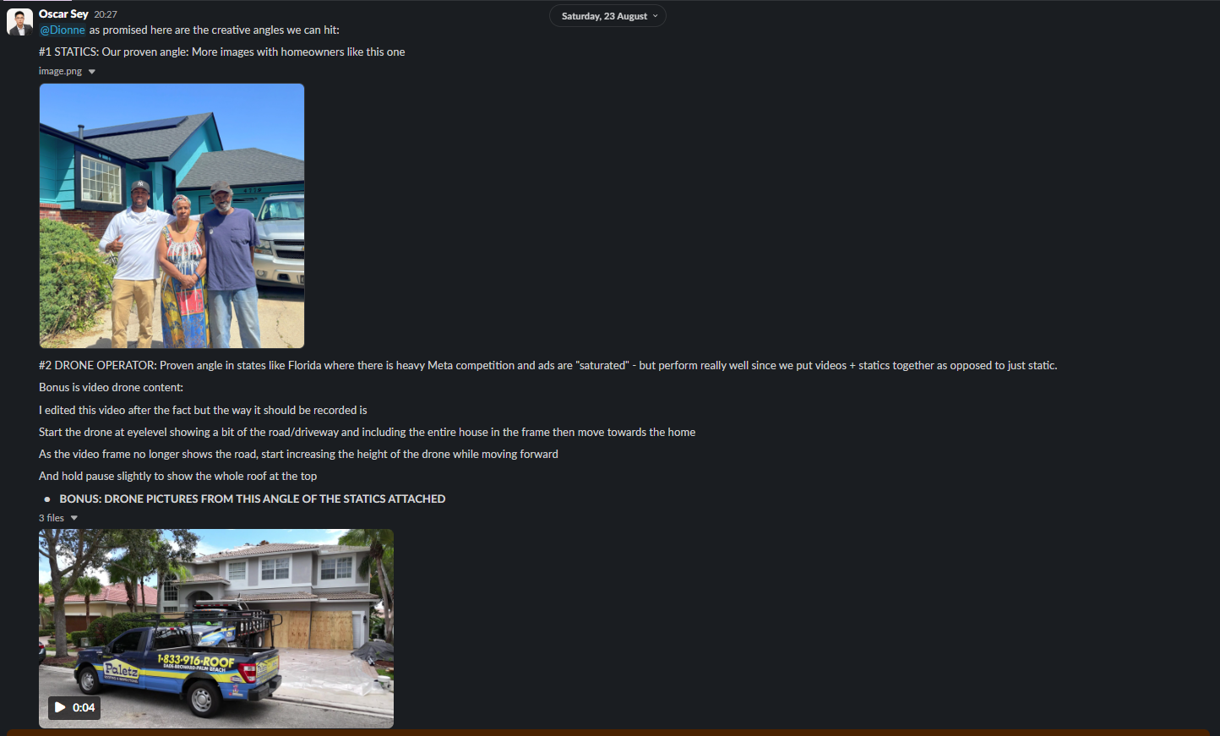
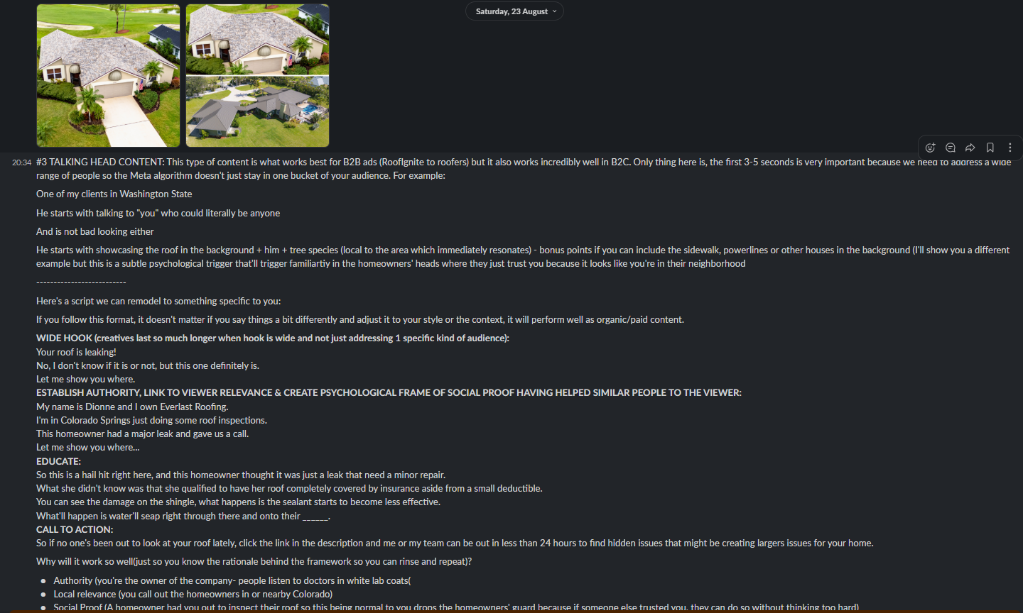

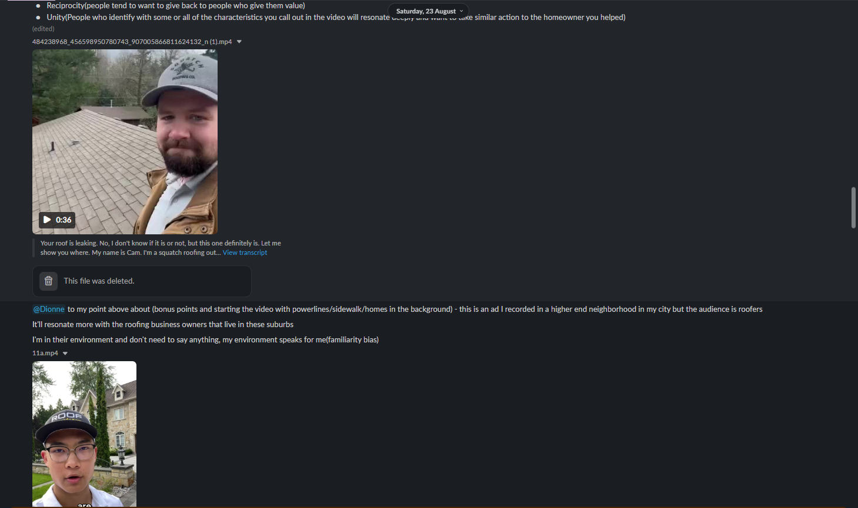
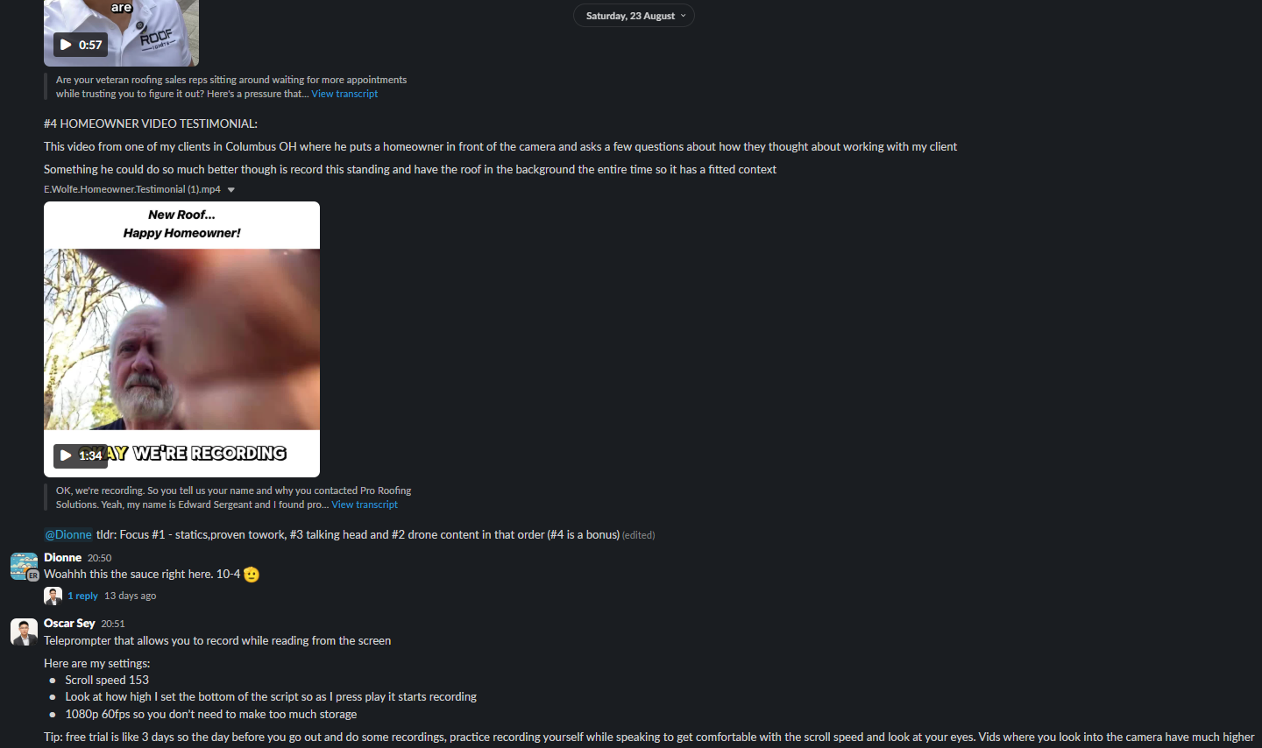

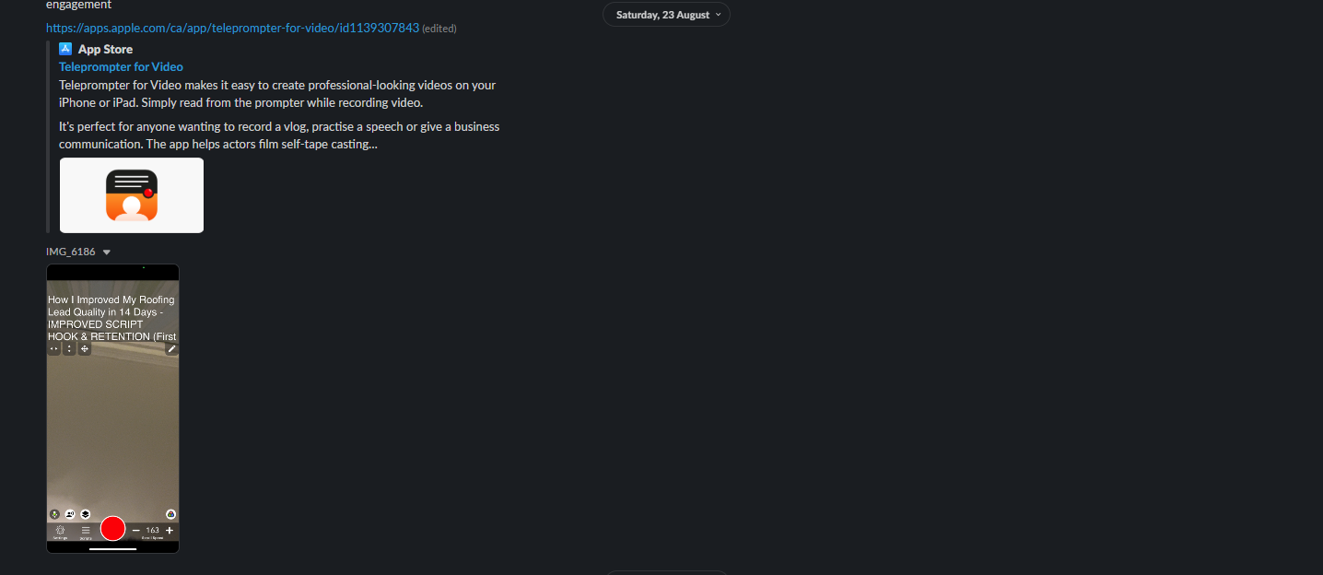

Hey, following our discussion about the recent Meta algorithm update that requires more sophisticated creatives in volume, here are RoofIgnite exemplars for how we want to see content from you!
#1 STATICS:
Our proven angle: Always looking for these proven images with homeowners like this one
- Add file here for Roofer With Homeowner Exemplar

#2 DRONE OPERATOR:
Proven angle in states like Florida where there is heavy Meta competition and ads are "saturated" - but perform really well since we put videos + statics together as opposed to just static.
- Add file here for Drone Video Exemplar

We edited this video after the fact but the way it should be recorded is:
- Start the drone at eyelevel showing a bit of the road/driveway and including the entire house in the frame then move towards the home
As the video frame no longer shows the road, start increasing the height of the drone while moving forward
And hold pause slightly to show the whole roof at the top

BONUS: DRONE PICTURES FROM THIS ANGLE OF THE STATICS ATTACHED. ROOF SHOULD BE ALREADY COMPLETED.
- Add file here for Bonus Drone Pic Angle 1
- Add file here for Bonus Drone Pic Angle 2

#3 TALKING HEAD CONTENT:
This type of content is what works best for B2B ads (RoofIgnite to roofers) but it also works incredibly well in B2C. Only thing here is, the first 3-5 seconds is very important because we need to address a wide range of people so the Meta algorithm doesn't just stay in one bucket of your audience. For example:

One of my clients in Washington State

He starts with talking to "you" who could literally be anyone

And is not bad looking either

He starts with showcasing the roof in the background + him + tree species (local to the area
which immediately resonates) - bonus points if you can include the sidewalk, powerlines or other houses in the background (I'll show you a different example but this is a subtle psychological trigger that'll trigger familiarity in the homeowners' heads where they just trust you because it looks like you're in their neighborhood.

--------------------------

Here's a script you can remodel to something specific to you:
If you follow this 4 STEP format, it doesn't matter if you say things a bit differently and adjust it to your style or the context of what you’re discussing in the video.

WIDE HOOK (creatives last so much longer when the audience hook is wide):
Your roof is leaking!

No, I don't know if it is or not, but this one definitely is.

Let me show you where.

ESTABLISH AUTHORITY, LINK TO VIEWER RELEVANCE & CREATE PSYCHOLOGICAL FRAME OF SOCIAL PROOF HAVING HELPED SIMILAR PEOPLE TO THE VIEWER:

My name is [OWNER NAME] and I own [COMPANY NAME].

I'm in [MAJOR CITY] just doing some roof inspections.

This homeowner had a major leak and gave us a call.

Let me show you where...

EDUCATE:
So this is a hail hit right here, and this homeowner thought it was just a leak that need a minor repair.

What she didn't know was that she qualified to have her roof completely covered by insurance aside from a small deductible.

You can see the damage on the shingle, what happens is the sealant starts to become less effective.

What'll happen is water'll seap right through there, through the underlayment and onto their decking. Not good.

CALL TO ACTION:
So if no one's been out to look at your roof lately, click the link in the description and me or my team can be out in less than 24 hours to find hidden issues that might be creating larger issues for your home.

—-----------------

Why will it work so well(just so you know the rationale behind the framework so you can rinse and repeat)?

- Authority (you're the owner of the company- people listen to doctors in white lab coats(
- Local relevance (you call out the homeowners in or nearby [CLIENT STATE])
- Social Proof (A homeowner had you out to inspect their roof so this being normal to you drops the homeowners' guard because if someone else trusted you, they can do so without thinking too hard)
- Reciprocity(people tend to want to give back to people who give them value)
- Unity(People who identify with some or all of the characteristics you call out in the video will resonate deeply and want to take similar action to the homeowner you helped)

- Add file here for Squatch Roofing "Your roof is leaking" hook
- Add file here for Everlast Roofing “Your roof is leaking” hook

To my point above about the psychology principles: Start the video with local tree species/powerlines/sidewalk/local style homes in the background

—---------

This is a B2B ad I recorded in a higher-end neighborhood in my city.
- Add file here for Oscar's B2B Example In High Status Authority Neighborhood
- Audience is established roofers and you can immediately tell why.
- It'll resonate more with the roofing business owners that live in these suburbs
- I'm in their environment and don't need to say anything, my environment speaks for me(familiarity bias, authority bias, they trust me more)

#4 HOMEOWNER VIDEO TESTIMONIAL:
This video from one of our clients in Columbus OH where he puts a homeowner in front of the camera and asks a few questions about how they thought about working with the client.

Something he could have done much better is record this standing and have the roof in the background the entire time. I’ve also attached an unedited example that shows an example of this (roof in background) detail.

- Add file here for Homeowner Testimonial (home-made style but missing roof in background)
- Add file here for Homeowner Testimonial with new roof in background

Also, I need to share something that will help you and your team film these new creatives so much easier:

Teleprompter that allows you to record while reading from the screen. I use this for my own B2B ads.
Here are my settings:
- Scroll speed 153
- Look at how high I set the bottom of the script so as I press play it starts recording
- 1080p 60fps so you don’t need to make too much storage

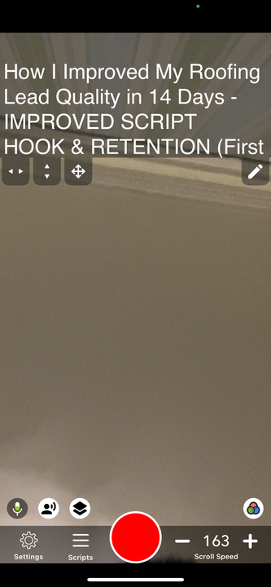
Tip: free trial is 3 days so the day before you go out and do some recordings, practice recording yourself while speaking to get comfortable with the scroll speed and look at your eyes. Vids where you look into the camera have much higher engagement
https://apps.apple.com/ca/app/teleprompter-for-video/id1139307843

Talking Head 0925 ACF
Ad Creation Framework Loom:
- 22 Home https://www.loom.com/share/274f278aaa954bf4931fb6281e41b74d
- Castle Home and VCS Roofing https://www.loom.com/share/a2ba2bf175e74758a55da0bd982ef244

22 Home Solutions - (50 miles of Tucson, AZ)
- Amazing social presence
Castle Home Restorations - New Haven CT (serves all CT)
- Firefighting experience and current occupation is firefighting (talk about local impact)
VCS Roofing & Construction - Northern Virginia
- Owner is incredibly detail oriented, William can do roof inspections really well and notice things that most can’t. Also is extensively knowledgeable about the insurance process

My goal:
- Use Manus to come up with great ad angle ideas that we can use to send to our clients to create educational/problem awareness ad creative scripts
  - Create high-converting ads

Working backwards:
- Feed your LLM with context and data on what works, what doesn’t work, the problems you are experiencing, be very thorough.
  - Give examples of previous ads, creatives that work, copy that doesn’t work in specific markets, some industry specific knowledge if you have it (For example, in FL, you need to get your roof replaced every 10-15 years or insurance will not cover you) - a lot of angles that come up there

- Start thinking about ways that we can implement unique characteristics of our clients.
- What type of jobs do these roofers want? Insurance? Retail?
- Final editing, ongoing help with Manus(usually what I do is break down the copy and ask Manus every time I make a significant improvement to actually look at my copy line by line and tell me what to improve further) - I do 10-20 iterations, minimum
- Send this to the rest of the team for their opinion (take everyone’s with a grain of salt, but principles in ad creations more or less stay the same always)

Work space:

22 Home Solutions - (50 miles of Tucson, AZ)

Angle 1: Installation Mistakes (Broad Appeal)
HOOK: "Your roof is leaking!"

"Ahh I don’t know if it is or not, but this one definitely is."

"Let me show you where."

AUTHORITY: "My name is [NAME], I'm the owner of [BUSINESS NAME]."

"I'm here in [NEIGHBORHOOD] doing an inspection for a homeowner who's having issues with their roof."

"They called us because their roof is only 3 years old but already having problems."

EDUCATE: "So look at this flashing around the vent. See how it's not sealed properly?"

What'll happen is water'll seep right through there, through the underlayment and onto their decking. Not good.

"The previous roofer didn't use the right technique for desert installations."

"In moderate climates, this might hold up. But with Tucson's thermal expansion, these gaps open up."

"This homeowner is going to have leaks during our next heavy rain because of this installation error."

CTA: "If your roof is having issues sooner than expected, it might be installation problems."

So if no one's been out to look at your roof lately, click the link in the description and me or my team can be out in less than 24 hours to find hidden issues that might be creating larger issues for your home.

Angle 2: Insurance Coverage Issues (Research Needed)
HOOK: "Did your roof get denied for insurance coverage?"

"This one did! Not because it's not damaged, but because of this one detail."

"Let me show you what insurance inspectors look for."

AUTHORITY: "My name is [NAME], I'm the owner of [BUSINESS NAME]."

"I'm here in [Neighborhood] helping a homeowner with their insurance inspection."

"Their previous roofer missed something that's now costing them coverage."

EDUCATE: "So insurance inspectors in Tucson look for specific things. This roof has [specific issue]."

"The previous contractor didn't know about Arizona insurance requirements."

"Now this homeowner can't get coverage until this is fixed properly." Luckily we were referred to them by their family friends and we’re gonna get them taken care of.

CTA: "So If you're having insurance issues or need an inspection because you haven’t had one lately, we know what adjusters look for."

We’ll be out in less than 24 hours to help you get taken care of.

Angle 3: Material Delivery/Pre-Installation
HOOK: “So you’re needing a new roof because your roof is failing or well on it’s way to:”

"Well, we just delivered materials for this roof replacement!"

"But before we start, this is why this roof needed to be replaced."

AUTHORITY: "My name is [NAME], I'm the owner of [BUSINESS NAME]."

"We're starting a replacement here in [Northwest Tucson] tomorrow."

EDUCATE: "These are the old shingles we're replacing. Look at this section here."

"This is what happens when you use standard materials in Tucson's climate."

***Talk about granular loss or other related climate impact on roofing materials***

"We're installing desert-rated materials that are specifically designed for extreme heat."

"The difference in longevity is going to be day and night for this homeowner."

CTA: "If your roof looks like this old one, it might be time to get your roof looked at."

So click on this post and myself or one of my team members would be happy to take care of you and be out within 24 hours.

Angle 4: Maintenance vs. Replacement
HOOK: "Did your roof make it through the last monsoon? Well this definitely didn’t!

AUTHORITY: "My name is [NAME], I'm the owner of [BUSINESS NAME]."

"I'm here in [Midtown Tucson] doing a roof inspection."

“This homeowner asked if they could just patch this!" *show specific area that needs repair*

"I had to show them why that won't work."

"They were hoping for a simple repair, but the damage is too extensive."

EDUCATE: "So you can patch individual shingles, but look at the overall condition."

"When more than 30% of your roof shows this level of deterioration, patches won't help."

"It's like putting a band-aid on a broken bone. The underlying problem remains."

"This homeowner will save money in the long run with full replacement now."

CTA: "So, if you haven’t had anyone out to take a look at your roof, or you’re experiencing issues, click here for a free inspection/estimate and myself or one of my team members would be glad to come out within 24 hours to get you taken care of."

Angle 5: Neighbor Comparison
HOOK: "This house and the neighbor's house were built the same year!"

"But look at the difference in their roofs."

"Let me show you why one is failing and one isn't."

AUTHORITY: "My name is [NAME], I'm the owner of [BUSINESS NAME]."

"I'm here in [Sahuarita] looking at two identical houses with very different roof conditions."

"Both built in YEAR_OF_INSTALLATION but only one needs replacement."

EDUCATE: "So this house used standard shingles. The neighbor used SPECIFIC DIFFERENT materials."

"Same installation year, same weather exposure, completely different results."

"The difference in material choice is costing this homeowner thousands extra in premature replacement."

"And that’s why material selection matters so much in Tucson's climate."

CTA: "So if your roof is aging faster than your neighbors', it might be the materials. Chances are, you don’t even know what’s going on up there if no one’s taken a look at in a while."

In any case, if wouldn’t hurt to get a second opinion

Click the link in the description and me or my team can be out in less than 24 hours to find hidden issues that might be creating larger issues for your home.

Castle Home Restorations - New Haven CT (serves all CT)
- Firefighting experience and current occupation is firefighting (talk about local impact)

Why did Mani bring up firefighter as a USP (unique selling point)

Why did Mani fixate on this idea over everything else(tell your story)

Combine the fact that they are firefighters + father-son business duo in their ads

Cost per appt floats between 188-220 for Brown Roofing

Mani said: $150/day 20-25apts/mo

We need to get a $210 Cost Per Appointment (Client prefers insurance over retail)

- Brown roofing is running these ads
Educational Videos Talking Head:
- BELOW

FAQ Content:
- TO BE ASKED

Copies to run(don’t mix the headlines/primary texts like we usually do):
- DEDUCTIBLE
- V1 from “Market Sophisticated tab”
  - But when it says owner name make sure to adjust copy slightly to say my name is Christian Diaz and my father David Diaz and I own Castle Home Restorations here in New Haven, CT. And by the way, we’re both firefighters part of the ***swap this out with the actual detail you get, this is just an example: “314th squadron xyz fire fighting dept”***!

Ad Campaign Buildout(we’re going to be testing something new):
- 1 campaign > 1 ad set > 10 ads
  - 6 statics(all should be extremely strong creatives) > Use V1 for 5/6 of the statics, and use DEDUCTIBLE for the 6/6th static (ensure this is the strongest image) - Exemplar for extremely strong creative here:
    - https://prnt.sc/vMRIgwX7smqo
  - 4 videos > Use the DEDUCTIBLE COPY for the insurance-related ad creative content Christian gives us which should be 3/4 of the videos
    - For the 4/4 video, use the V1 copy

Client Message to Christian:
Hey Christian,

Oscar wanted me to send you these 4 video script frameworks that have been crushing it for our other roofing clients. We've adapted them specifically for Connecticut and your unique background as a firefighter.

The key is filming in recognizable Connecticut neighborhoods with local visual elements - think colonial homes, mature trees, stone walls, and New England architecture that immediately creates familiarity with homeowners.

Your firefighting background gives you incredible authority and trust - use it! People trust firefighters more than almost any other profession.

Here are the frameworks:

3 INSURANCE-FOCUSED SCRIPTS:

Script 1: Insurance Claim Process Education
HOOK (3-5 seconds): "Your roof is leaking"

"Ah I don't know if yours is or not, but this one definitely is."

"Let me show you where."

AUTHORITY + LOCAL RELEVANCE: "My name is Christian, I'm the owner of Castle Home Restorations, also a firefighter here in New Haven, so I see storm damage all the time."

"I'm here in [A Major City] doing a roof inspection

This homeowner had a major leak and gave us a call.

Let me show you where...

EDUCATE: "So this is a hail hit right here, and this homeowner thought it was just a leak that need a minor repair. See these impact marks?

Look, what she didn't know was that she qualified to have her roof completely covered by insurance aside from a small deductible.

You can see the damage on the shingle, what happens is the sealant starts to become less effective.

What'll happen is water'll seap right through there, through the underlayment and onto their decking. Not good.
At the end of the day, we don't want your roof looking like this.
You guys already have the protection, and it's your insurance.
And unfortunately, most people are paying premiums every year and paying more for it every year, despite whether they put a claim in or not.
So when you do have an opportunity to actually use your insurance, I would take it because you’re going to be paying for your premiums every month, every year regardless.
And when it does hail and when your roof is damaged, they're not out here letting you know.
CALL TO ACTION:
So if no one's been out to look at your roof lately, click this post and I can be out in less than 24 hours to help you find hidden damage that might be creating larger issues for your home!

Script 2: Rate Increase Fears
HOOK: "This homeowner was hesitant to file a claim for their roof!"

"And it’s because they thought their premiums would skyrocket!"

“And you know what? That’s a fair concern…”

“But that’s not exactly how it works. Let me tell you the truth about insurance rate increases."

AUTHORITY + LOCAL RELEVANCE: "My name is Christian, I'm the owner of Castle Home Restorations and I’m also a New Haven firefighter."

"I'm here in [A Major City] on a roof inspection with a homeowner who almost didn't file their claim."

"And t’s because they were worried about their insurance rates going up."

EDUCATE: "Here's what I told them as both a roofer and someone who sees storm damage issues daily:"

"Your rates are going up anyway, whether you file a claim or not."

"You're already paying premiums every month. And when you have legitimate damage, that's what insurance is for."

"And to replace this storm damaged roof? It would’ve costed $18,000 out of pocket! Their deductible? $1,500."

“You guys already have the protection, and it's your insurance.
So when you do have an opportunity to actually use your insurance, I would take it because you’re going to be paying for your premiums every month, every year regardless.
And when it does hail and when your roof is damaged, they're not out here letting you know.
CTA: So if no one's been out to look at your roof lately, click this post and I can be out in less than 24 hours to help you find hidden damage that might be creating larger issues for your home and help with the claim process!

Script 3: Discontinued Shingles
HOOK: "Your roof is irreparable!”

“Ahh, I’m not sure if it can or not but this roof definitely can't be repaired!"

"Not because the damage is too bad, but because these shingles don't exist anymore."

"So if your shingles look like this, let me tell you about these discontinued shingles and why it matters to you."

AUTHORITY + LOCAL RELEVANCE: "My name is Christian, I'm the owner of Castle Home Restorations and I’m also a firefighter in New Haven."

"I'm here in [A Major City] doing a roof inspection with a homeowner who has shingles that are discontinued."

"This homeowner thought they could just replace the damaged section. See this damaged section here?"

EDUCATE: "So these are three-tab shingles from the 1990s.

The manufacturer discontinued this exact style years ago."

"Here’s the good news: The companies that are ultimately responsible for helping you pay for a new roof know that when shingles are discontinued, they need to cover your roof for a full replacement."

"You can't match discontinued shingles, and mismatched repairs look like a sore eye!"

"So, this homeowner is getting their entire roof replaced because it was leaking and their shingles are discontinued."

And in this homeowner’s case, her deductible was $1000, much less than the actual cost it would have taken to repair this section.

CTA: So if you’re having issues with your roof, or if you even have shingles that look like these, click this post and I can be out in less than 24 hours to help you find hidden damage that might be creating larger issues for your home!

1 RETAIL-FOCUSED SCRIPT:

Script 4: Preventive Maintenance
HOOK: "Did your roof make it through the storm?”

This one definitely didn’t! What’s crazy is that the roof looked fine from the ground!”

"But up here, I can see it's got maybe 2 years left."

"Let me show you what you might not be seeing from the street level."

AUTHORITY + LOCAL RELEVANCE: "My name is Christian, I'm the owner of Castle Home Restorations and I’m also a New Haven firefighter."

"I'm out here in [A Major City] doing free inspections for people."

"This homeowner called because they're thinking about selling their home in a few years."

EDUCATE: "And the roof looks decent from the street. But come take look at these shingles up close."

"See the granule loss?"

"This roof will fail within 2 years, probably during a nor'easter when you’ll least expect it!"

"And what the majority of people don’t realize is:

Oftentimes roofs have hidden damages that go unnoticed.

And more often than that, these damages are impossible to spot from the ground,

Let alone by an untrained eye.

What’s worse? Not spotting these issues can lead to totally avoidable damages that end up costing homeowners THOUSANDS more when they could have prevented it.

And that’s where we come in:

CTA: “If no one's been out to look at your roof lately, click on this post and I can be out in less than 24 hours to help you find any hidden damage that might be creating larger issues for your home!”

Christian, these scripts leverage your unique firefighter background while addressing the specific challenges Connecticut homeowners face. Your credibility as both a firefighter and local business owner gives you incredible authority.

Feel free to adapt the language to your natural speaking style, but keep the 4-step structure: Hook → Authority → Educate → CTA.

Let me know if you want Oscar to review your first video before you film the rest!

VCS Roofing & Construction - Northern Virginia
- Owner is incredibly detail oriented, William can do roof inspections really well and notice things that most can’t. Also is extensively knowledgeable about the insurance process

Copies to run(don’t mix the headlines/primary texts like we usually do):
- DEDUCTIBLE
- V1 from “Market Sophisticated tab”

Ad Campaign Buildout(we’re going to be testing something new):
- 1 campaign > 1 ad set > 10 ads
  - 6 statics(all should be extremely strong creatives) > Use V1 for 5/6 of the statics, and use DEDUCTIBLE for the 6/6th static (ensure this is the strongest image) - Exemplar for extremely strong creative here:
    - https://prnt.sc/vMRIgwX7smqo
  - 4 videos > Use the DEDUCTIBLE COPY for the insurance-related ad creative content William gives us which should be 3/4 of the videos
    - For the 4/4 video, use the V1 copy

Client Message to William:
Hey William,

Oscar wanted me to send you these 4 video script frameworks that have been crushing it for our other roofing clients. We've adapted them specifically for NoVa and your unique background as a firefighter.

The key is filming in recognizable NoVa neighborhoods with local visual elements - think colonial homes, mature trees, stone walls, and New England architecture that immediately creates familiarity with homeowners.

Your extensive insurance process knowledge gives you incredible authority and trust - use it! We’re in a trust recession, and in your market specifically where the % of homeowners being educated and more buyer aware is higher, people want to see authenticity and education content.

Here are the frameworks:

3 INSURANCE-FOCUSED SCRIPTS:

Script 1: Insurance Claim Process Education
HOOK (3-5 seconds): "Your roof is leaking!"

"Ah I don't know if yours is or not, but this one definitely is."

"Let me show you where."

AUTHORITY + LOCAL RELEVANCE: "My name is William, I'm the owner of VCS Roofing and Construction."

"I'm here in [A Major City] doing a roof inspection

This homeowner had a major leak and gave us a call.

Let me show you where...

EDUCATE: "So this is a hail hit right here, and this homeowner thought it was just a leak that need a minor repair. See these impact marks?

Look, what she didn't know was that she qualified to have her roof completely covered by insurance aside from a small deductible.

You can see the damage on the shingle, what happens is the sealant starts to become less effective.

What'll happen is water'll seap right through there, through the underlayment and onto their decking. Not good.
At the end of the day, we don't want your roof looking like this.
You guys already have the protection, and it's your insurance.
And unfortunately, most people are paying premiums every year and paying more for it every year, despite whether they put a claim in or not.
So when you do have an opportunity to actually use your insurance, I would take it because you’re going to be paying for your premiums every month, every year regardless.
And when it does hail and when your roof is damaged, they're not out here letting you know.
CALL TO ACTION:
So if no one's been out to look at your roof lately, click this post and I can be out in less than 24 hours to help you find hidden damage that might be creating larger issues for your home!

Script 2: Rate Increase Fears
HOOK: "This homeowner was hesitant to file a claim for their roof!"

"And it’s because they thought their premiums would skyrocket!"

“And you know what? That’s a fair concern…”

“But that’s not exactly how it works. Let me tell you the truth about insurance rate increases."

AUTHORITY + LOCAL RELEVANCE: "My name is William, I'm the owner of VCS Roofing and Construction."

"I'm here in [A Major City] on a roof inspection with a homeowner who almost didn't file their claim."

"And t’s because they were worried about their insurance rates going up."

EDUCATE: "Here's what I told them as both a roofer and someone who sees storm damage issues daily:"

"Your rates are going up anyway, whether you file a claim or not."

"You're already paying premiums every month. And when you have legitimate damage, that's what insurance is for."

"And to replace this storm damaged roof? It would’ve costed $18,000 out of pocket! Their deductible? $2,500."

“You guys already have the protection, and it's your insurance.
So when you do have an opportunity to actually use your insurance, I would take it because you’re going to be paying for your premiums every month, every year regardless.
And when it does hail and when your roof is damaged, they're not out here letting you know.
CTA: So if no one's been out to look at your roof lately, click this post and I can be out in less than 24 hours to help you find hidden damage that might be creating larger issues for your home and help with the claim process!

Script 3: Discontinued Shingles
HOOK: "Your roof is irreparable!”

“Ahh, I’m not sure if it can or not but this roof definitely can't be repaired!"

"Not because the damage is too bad, but because these shingles don't exist anymore."

"So if your shingles look like this, let me tell you about these discontinued shingles and why it matters to you."

AUTHORITY + LOCAL RELEVANCE: "My name is William, I'm the owner of VCS Roofing and Construction."

"I'm here in [A Major City] doing a roof inspection with a homeowner who has shingles that are discontinued."

"This homeowner thought they could just replace the damaged section. See this damaged section here?"

EDUCATE: "So these are three-tab shingles from the 1990s.

The manufacturer discontinued this exact style years ago."

"Here’s the good news: The companies that are ultimately responsible for helping you pay for a new roof know that when shingles are discontinued, they need to cover your roof for a full replacement."

"You can't match discontinued shingles, and mismatched repairs look like a sore eye!"

"So, this homeowner is getting their entire roof replaced because it was leaking and their shingles are discontinued."

And in this homeowner’s case, her deductible was $1000, much less than the actual cost it would have taken to repair this section.

CTA: So if you’re having issues with your roof, or if you even have shingles that look like these, click this post and I can be out in less than 24 hours to help you find hidden damage that might be creating larger issues for your home!

1 RETAIL-FOCUSED SCRIPT:

Script 4: Preventive Maintenance
HOOK: "Did your roof make it through the storm?”

This one definitely didn’t! What’s crazy is that the roof looked fine from the ground!”

"But up here, I can see it's got maybe 2 years left."

"Let me show you what you might not be seeing from the street level."

AUTHORITY + LOCAL RELEVANCE: "My name is William, I'm the owner of VCS Roofing and Construction."

"I'm out here in [A Major City] doing free inspections for people."

"This homeowner called because they're thinking about selling their home in a few years."

EDUCATE: "And the roof looks decent from the street. But come take look at these shingles up close."

"See the granule loss?"

"This roof will fail within 2 years, probably during a nor'easter when you’ll least expect it!"

"And what the majority of people don’t realize is:

Oftentimes roofs have hidden damages that go unnoticed.

And more often than that, these damages are impossible to spot from the ground,

Let alone by an untrained eye.

What’s worse? Not spotting these issues can lead to totally avoidable damages that end up costing homeowners THOUSANDS more when they could have prevented it.

And that’s where we come in:

CTA: “If no one's been out to look at your roof lately, click on this post and I can be out in less than 24 hours to help you find any hidden damage that might be creating larger issues for your home!”

William, these scripts leverage your extensive insurance process knowledge while addressing the specific concerns homeowners here have which are that their premiums will rise if they do file a claim. Your credibility as a local business owner gives you incredible authority.

Adapt the language to your natural speaking style as you see fit, but non-negotiable:

Keep the 4-step structure: Hook → Authority → Educate → CTA.

Let me know if you want Oscar to review your first video before you film the rest!

Outstanding Roofing

Outstanding Roofing

Angle 1: Installation Mistakes (Broad Appeal)
HOOK: "Your roof is leaking!"

"Ahh I don’t know if it is or not, but this one definitely is."

"Let me show you where."

AUTHORITY: "My name is [NAME], I'm the owner of [BUSINESS NAME]."

"I'm here in [NEIGHBORHOOD] doing an inspection for a homeowner who's having issues with their roof."

"They called us because their roof is only 3 years old but already having problems."

EDUCATE: "So look at this flashing around the vent. See how it's not sealed properly?"

What'll happen is water'll seep right through there, through the underlayment and onto their decking. Not good.

"The previous roofer didn't use the right technique for desert installations."

"In moderate climates, this might hold up. But with Tucson's thermal expansion, these gaps open up."

"This homeowner is going to have leaks during our next heavy rain because of this installation error."

CTA: "If your roof is having issues sooner than expected, it might be installation problems."

So if no one's been out to look at your roof lately, click the link in the description and me or my team can be out in less than 24 hours to find hidden issues that might be creating larger issues for your home.

Angle 2: Material Delivery/Pre-Installation
HOOK: “Your roof is failing! Or maybe well on it’s way to!
AUTHORITY: "My name is [NAME], I'm the owner of [BUSINESS NAME]."

"As you can see behind me, we just delivered materials for this roof replacement!"

"We're starting a replacement here in [neighbourhood] tomorrow."

EDUCATE: "These are the old shingles we're replacing. Look at this section here."

"This is what happens when you use standard materials in Toronto climate."

***Talk about granular loss or other related climate impact on roofing materials***

"We're installing materials that are specifically designed for the winter cold."

"The difference in longevity is going to be day and night for this homeowner."

CTA: "If your roof looks like this old one, it might be time to get your roof looked at."

So click on this post and myself or one of my team members would be happy to take care of you and be out within 24 hours.

Angle 3: Maintenance vs. Replacement
HOOK: "Did your roof make it through the Winter? Well this definitely didn’t!

AUTHORITY: "My name is [NAME], I'm the owner of [BUSINESS NAME]."

"I'm here in [neighbourhood] doing a roof inspection."

“This homeowner asked if they could just patch this!" *show specific area that needs repair*

"I had to show them why that won't work."

"They were hoping for a simple repair, but the damage is too extensive."

EDUCATE: "So you can patch individual shingles, but look at the overall condition."

"When more than 30% of your roof shows this level of deterioration, patches won't help."

"It's like putting a band-aid on a broken bone. The underlying problem remains."

"This homeowner will save money in the long run with full replacement now."

CTA: "So, if you haven’t had anyone out to take a look at your roof, or you’re experiencing issues, click here for a free inspection/estimate and myself or one of my team members would be glad to come out within 24 hours to get you taken care of."

Angle 4: Neighbor Comparison
HOOK: "This house and the neighbor's house were built the same year!"

"But look at the difference in their roofs."

"Let me show you why one is failing and one isn't."

AUTHORITY: "My name is [NAME], I'm the owner of [BUSINESS NAME]."

"I'm here in [neighbourhood] looking at two identical houses with very different roof conditions."

"Both built in YEAR_OF_INSTALLATION but only one needs replacement."

EDUCATE: "So this house used standard shingles. The neighbor used SPECIFIC DIFFERENT materials."

"Same installation year, same weather exposure, completely different results."

"The difference in material choice is costing this homeowner thousands extra in premature replacement."

"And that’s why material selection matters so much in Toronto climate."

CTA: "So if your roof is aging faster than your neighbors', it might be the materials. Chances are, you don’t even know what’s going on up there if no one’s taken a look at in a while."

In any case, if wouldn’t hurt to get a second opinion

Click the link in the description and me or my team can be out in less than 24 hours to find hidden issues that might be creating larger issues for your home.

